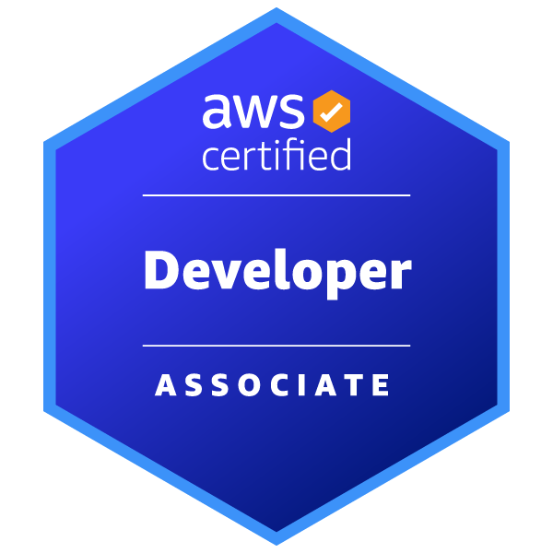
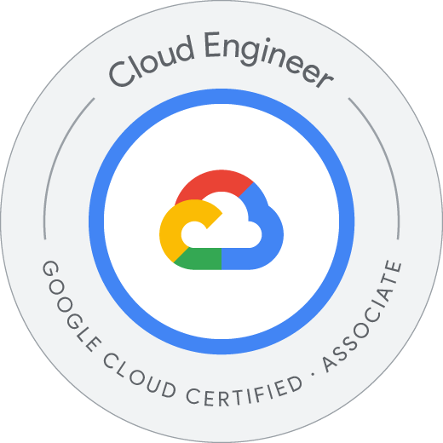
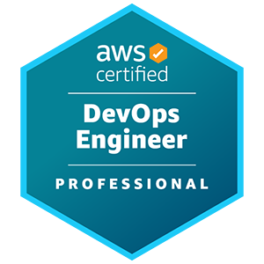
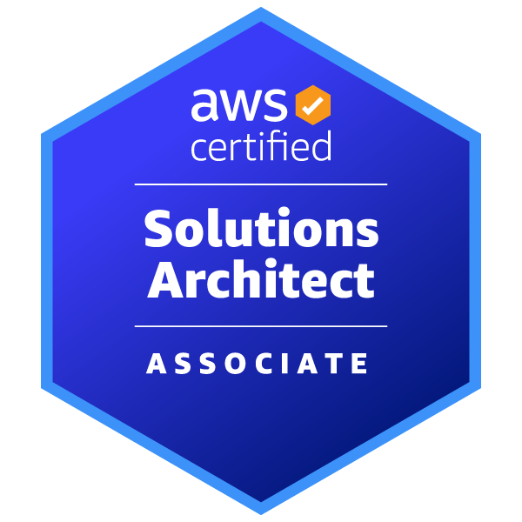
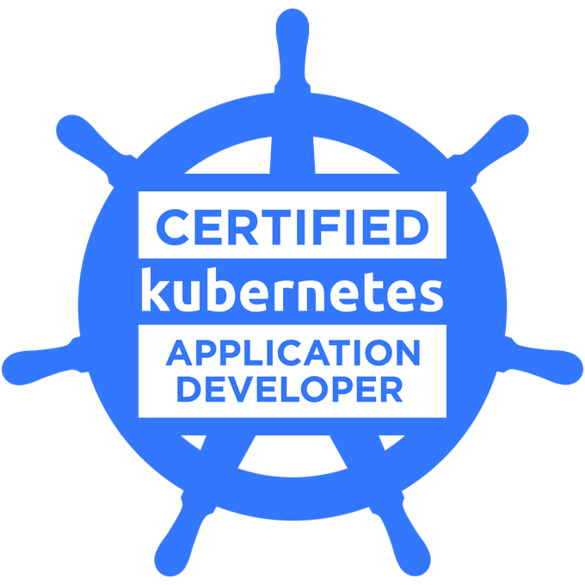
Ushna Akram

Senior DevSecOps Engineer

Email: ushna.akram1@gmail.com | ushnaakram.me

Lancaster University Graduate - B.S. Software Engineer

Summary
With over five years as a DevOps Engineer, I specialize in AWS, Azure, and GCP, designing robust cloud architectures and managing CI/CD pipelines using tools like Jenkins and GitHub Actions. Proficient in Infrastructure as Code with Terraform and AWS CloudFormation, I excel in containerization using Docker and Kubernetes, and automation with Python and Bash. I ensure system reliability through monitoring tools like Datadog and Grafana, optimize cloud costs with AWS Cost Explorer, and uphold security best practices using tools such as Istio Service Mesh. A collaborative professional, I leverage platforms like GitHub and JIRA to drive continuous improvement and efficiency.

Skills
Cloud: AWS, Azure, GCP, Cloudflare
Containers: Docker, Kubernetes, Helm, EKS, ECS
CI/CD: Jenkins, GitHubActions, CircleCI, ArgoCD,CodePipeline
IaC: Terraform, AWS CloudFormation, AWS CDK
Config Mgmt: Ansible, Puppet, Chef
Programming: Python, Golang, TypeScript, Bash
Serverless: AWS Lambda, Serverless Framework, APIGateway
Security: Istio, AWS Well-Architected Framework, Cost Optimization
Collaboration: GitHub,GitLab, BitBucket, Confluence, JIRA,Trello
Monitoring: Datadog, Splunk, Grafana, Prometheus, AWS CloudWatch, NewRelic

Certifications
- AWS Certified DevOps Engineer - Professional
- AWS Certified Solutions Architect - Associate
- AWS Certified Developer - Associate
- Google Cloud - Associate Cloud Engineer
- Certified Kubernetes Application Developer

Experience
Senior DevSecOps Engineer (DevSecOps Engineer) - Freelance (2024 – Present)
- Managed AWS APIs with EventBridge rules and Lambdas for custom actions on API calls.
- Set up threat detection alerts on API calls with notifications via MSTeams, Slack, and Google Chat and integrated with PagerDuty and AzureCloud for extended analysis.
- Enabled auto-remediation for security threats (e.g., re-enabling S3 Public Access Block, removing open SSH rules on public EC2s) and created SCPs to block resource creation when specific conditions (like missing tags) are not met
- Implemented auto-tagging for resources lacking required tags.
- Generated resource reports for SSO users who were disabled or removed and tracked IPs of SSO user logins, sent threat alerts on failed logins or brute force attempts, and supported Tailscale IP tracking.
- Produced daily, weekly, and monthly cost reports for active resources by user
- Calculated IP addresses for VPC CIDRs using Netbox (IPAM)
- Created new GovCloud accounts and provisioned required resources with Terraform
- Ran custom scripts on EC2 launches using Central SSM Documents
- Designed & implemented secure, scalable AWS architectures (EKS, ECS, EC2, S3, CloudFront) using Terraform, AWS CDK & CDK-TF
- Built & maintained CI/CD pipelines with Jenkins, GitHub Actions, CircleCI, & AWS CodePipeline improving release cycles
- Performed cost analysis and devised strategies to optimize cloud spend without compromising performance
- Collaborated with clients to deliver tailored solutions, comprehensive documentation, and training for smooth handovers
Senior DevOps Engineer (DevSecOps Engineer) - Kaleidoscope (2023 – 2024)
- Optimized infrastructure to increase efficiency and reliability.
- Migrated CI/CD pipelines from GitLab to GitHub Actions for streamlined processes.
- Implemented cost-saving measures enhancing infrastructure cost-efficiency.
- Developed an organization-wide API tracking solution to monitor system performance.
- Enhanced Golang applications to improve functionality and performance.
- Led Terragrunt-based infrastructure setup for multiple client environments, ensuring scalability.
- Set up Cloud9 environments, facilitating efficient deployments and improving workflows at Kaleidoscope.
DevOps Engineer (DevSecOps Engineer/Python Developer) - Enquizit (2019 – 2023)
- Collaborated with design teams to develop and enhance software functionality and performance.
- Managed CI/CD pipelines, overseeing automated builds and resolving release issues.
- Developed infrastructure using CloudFormation, Terraform, and CDK.
- Created cross-platform tools and integrations to meet user needs.
- Migrated infrastructure to AWS from on-premises and other clouds.
- Containerized microservices with Docker and deployed using Kubernetes, EKS, and ECS.
- Built serverless applications with AWS Lambda (Python) and GCP Cloud Functions, integrating with key services.
- Automated deployments using CloudDeploy with YAML configurations.
- Managed GCP services like Compute Engine, BigQuery, and Load Balancing.

